Join us on May 23-24, 2022, for the 36th Annual Music City Golf Tournament. This event benefits the programs of Ronald McDonald House Charities (RMHC) of Nashville.

On the evening of Monday, May 23rd, we will kick off the festivities with the Music City Dinner and Auction at Top Golf Nashville in downtown Nashville with an exciting evening of fine cocktails, a delicious dinner, unique silent auction, networking and friendly competition throughout the golf bays! All golfers will also receive a complimentary hotel stay for the night of May 23rd at the Cambria Hotel.

The events on Tuesday, May 24th include a round of golf at The Governor’s Club complete with breakfast, on-course refreshments, lunch, golfer gifts and the 19th Hole Cocktail and Awards Reception.
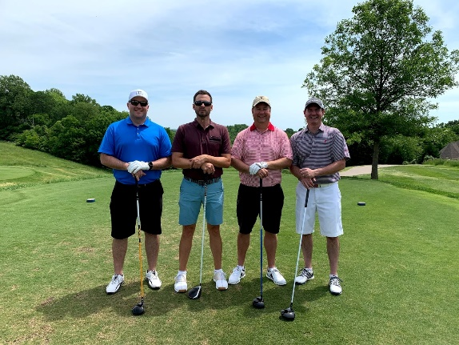
Sponsorships and golfer spots may be purchased online at rmhcnashville.com.

Prices
-Individual Golfer Spots are available for $2,000
-Playing Sponsorships range from $8,000- $50,000
-Non-Playing Sponsorships range from $150- $5,000

How You Can Help:
Sponsorship – Ranging from $150 to $50,000, these sponsorship packages allow your company name to be associated with the Music City Golf Tournament prior to and during the event. Call 615-343-4000 or email amy@rmhcnashville.com for information.

Auction Item Donation– Consider donating an item, experience, gift card, etc. to be included in the event’s silent auction. In return for your tax-deductible donation, you will receive acknowledgement in the electronic event program and on the event website.

Corporate Matching Program – As an employer, you may choose to pay for all or a portion of your employees’ entry fee or provide matching funds for the entry fees. This is a great way to show your corporation’s commitment to families of critically ill children.

Music City Golf Tournament Sponsorship Opportunities
May 23 & 24, 2022

Playing Sponsorships

$50,000 Title Sponsor (Limit 1)
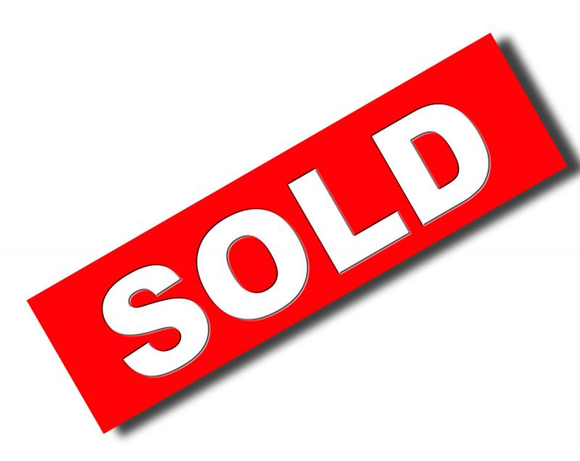
- Corporate name featured prior to the event title
- Corporate logo prominently featured on invitations and the event program
- Logo featured on gift for golfers
- Recognition and opportunity for Company Official to make remarks at the Music City Dinner and Auction
- 12 Golfer Spots and Golfer Gifts
- Most prominent full-screen ad in the day-of event program
- Two Tee/Hole Signs on the golf course
- Name and/or logo prominently featured in news releases, promotional ads, and on the RMHC website
- Sponsor signage prominently displayed at the Music City Dinner and Auction
- Sponsor signage prominently displayed at tournament
- Recognition at the 19th Hole Cocktail and Awards Reception at Governor’s Club
- 24 tickets to the Music City Dinner and Auction
- Three reserved bays at Top Golf Nashville
- 24 tickets to the 19th Hole Cocktail and Awards Reception at Governor’s Club
- 12 complimentary hotel rooms at Cambria Hotel (deadline to confirm is April 16)

$25,000 Presenting Sponsor (Limit 2)
- Corporate name featured following the event title
- Corporate logo featured on invitations and the event program
- 8 Golfer Spots and Golfer Gifts
- Prominent full-screen ad in the day-of event program
- Two Tee/Hole Signs on the golf course
- Name and/or logo included in news releases, promotional ads, & the RMHC website
- Sponsor signage displayed at the Music City Dinner and Auction
- Sponsor signage displayed at tournament
- Recognition at the 19th Hole Cocktail and Awards Reception at Governor’s Club
- 16 tickets to the Music City Dinner and Auction
- Two reserved bays at Top Golf Nashville
- 16 tickets to the 19th Hole Cocktail and Awards Reception at Governor’s Club
- 8 complimentary hotel rooms at Cambria Hotel (deadline to confirm is April 16)

$13,000 Premier Sponsor Benefits (Limit 3)
- Corporate logo featured on invitations and the event program
- Product display and giveaway opportunities at the Music City Dinner and Auction and the 19th Hole Cocktail and Awards Reception
- Sponsor may provide an item with the company logo to be distributed in goody bags
- Sponsor may provide a giveaway item on a designated par 3 hole on the golf course and any applicable signage at that hole
- Prominent full-screen ad in the day-of event program
- Two Tee/Hole Signs on the golf course
- Name and/or logo included in news releases, promotional ads, & on the RMHC website
- Sponsor signage displayed at the Music City Dinner and Auction
- Sponsor signage displayed at tournament
- Recognition at the 19th Hole Cocktail and Awards Reception at Governor’s Club
- 4 Golfer Spots and Golfer Gifts
- 8 tickets to the Music City Dinner and Auction
- Two reserved bays at Top Golf Nashville
- 8 tickets to the 19th Hole Cocktail and Awards Reception at Governor’s Club
- 4 complimentary hotel rooms at Cambria Hotel (deadline to confirm is April 16)

$13,000 Music City Dinner & Auction Sponsor (Limit 3)
- Corporate logo featured on invitations and the event program
- Product display and giveaway opportunities at the Music City Dinner and Auction and the 19th Hole Cocktail and Awards Reception
- 4 Golfer Spots and Golfer Gifts
- Prominent full-screen ad in the day-of event program
- Two Tee/Hole Signs on the golf course
- Name and/or logo included in news releases, promotional ads, & the RMHC website
- Sponsor signage displayed at the Music City Dinner and Auction
- Sponsor signage displayed at tournament
- Recognition at the 19th Hole Cocktail and Awards Reception at Governor’s Club
- 8 tickets to the Music City Dinner and Auction
- One reserved bay at Top Golf Nashville
- 8 tickets to the 19th Hole Cocktail and Awards Reception at Governor’s Club
- 4 complimentary hotel rooms at Cambria Hotel (deadline to confirm is April 16)

$10,000 “19th Hole” Cocktail Awards Reception Sponsor (Limit 3)
- Signage and recognition at the 19th Hole Cocktail and Awards Reception
- Full-screen ad in day-of event program
- 4 Golfer Spots and Golfer Gifts
- One Tee/Hole Sign on the golf course
- Name and/or logo featured in news releases, promotional ads & the RMHC website
- Sponsor signage displayed at the Music City Dinner and Auction
- Recognition at the 19th Hole Cocktail and Awards Reception at Governor’s Club
- 8 tickets to the Music City Dinner and Auction
- One reserved bay at Top Golf Nashville
- 8 tickets to the 19th Hole Cocktail and Awards Reception at Governor’s Club
- 4 Complimentary Hotel Rooms at Cambria Hotel (deadline to confirm is April 16)

$8,000 Corporate Sponsor
- 4 Golfer Spots and Golfer Gifts
- Full-screen ad in day-of event program
- One Tee/Hole Sign on the golf course
- Name and/or logo featured in news releases, promotional ads, and on the RMHC website
- Sponsor signage displayed at the Music City Dinner and Auction
- Recognition at the 19th Hole Cocktail and Awards Reception at Governor’s Club
- 8 tickets to the Music City Dinner and Auction
- 8 tickets to the 19th Hole Cocktail and Awards Reception at Governor’s Club
- 4 Complimentary Hotel Rooms at Cambria Hotel (deadline to confirm is April 16)

$2,000 Individual Golfer
- 1 Golfer Spot and Golfer Gift
- 2 tickets to the Music City Dinner and Auction
- Acknowledgement in the day-of event program
- 2 tickets to the 19th Hole Cocktail and Awards Reception at Governor’s Club
- 1 complimentary hotel room at Cambria Hotel (deadline to confirm is April 16)

Non-Playing Sponsorships
$5,000 Goody Bag Sponsor
- Company logo or name on all golfer goody bags
- Signage on goody bag table in registration area
- Logoed item (provided by sponsor) to be distributed in the goody bags
- Full-screen ad in day-of event program

$3,000 Breakfast Sponsor
- Signage in breakfast area throughout breakfast and registration
- Full-screen ad in day-of event program

$3,000 Lunch Sponsor
- Signage in lunch area throughout the day after lunch setup
- Full-screen ad in day-of event program

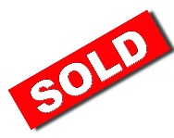
$1,500 Beverage Cart Sponsor (Limit 2)
- Signage on beverage carts circulating the course and beverage stations
- Half-screen ad in day-of event program

$1,500 On-Course Contests Sponsor
- Signage at each contest (hole-in-one, straightest & longest drives, closest to the pin)
- Sponsor table at the water hazard hole with giveaways (optional)
- Half-screen ad in day-of event program

$500 Hole-in-One Sponsor
- Signage at each par-3 hole-in-one contest site
- Half-screen ad in day-of event program

$500 Putting Contest Sponsor
- Signage at putting green
- Sponsor giveaways at the putting green (optional)
- Half-screen ad in day-of event program

$500 Water Hazard Sponsor
- Signage at water hazard hole
- Sponsor giveaways at the water hazard hole (optional)
- Half-screen ad in day-of event program

$300 Tee/Hole Sign
- One Tee/Hole Sign on the Golf Course
- Half-screen ad in the day-of event program

Sponsor and Golfer Registration

Please complete and return this form to Ronald McDonald House Charities of
Nashville by mail, email to amy@rmhcnashville.com or fax to (615) 343-4004.

Playing Sponsorships

___ Yes, I would like to participate as the (circle one):

Title Sponsor • Presenting Sponsor • Premier Sponsor • Music City Dinner & Auction Sponsor

“19th Hole” Cocktail Awards Reception Sponsor • Corporate Sponsor

___ Yes, I would like to participate with ____ Individual Golfer Spots at $2,000 each

Non-Playing Sponsorships (no golfer spots included)

___ Yes, I would like to participate as a (circle one or more):

Goody Bag Sponsor • Breakfast Sponsor • Lunch Sponsor • Beverage Cart Sponsor

On-Course Contests Sponsor • Air Cannon Sponsor • Hole-in-One Sponsor •

Putting Contest Sponsor • Water Hazard Sponsor • Tee/Hole Sign Sponsor

___ Yes, I would like to participate as an Electronic Ad Sponsor with the following (circle one):

$300 Full-Screen Ad • $150 Half-Screen Ad • $75 Quarter Screen Ad

___ Yes, I would like to purchase ____ Music City Dinner & Auction Tickets at $150 each.

___ No, I am unable to participate, but enclosed is my donation in the amount of: ____ $1,000 ____ $500 ____$250 ____ Other

Name_________________________________________________________________

Email _______________________________________________________________

Company _____________________________________________________________

Address ___________________________ City______________ State ___ Zip ________

Contact for Golfers Info: Name_____________________ Email______________________

Work Phone _________________ Cell Phone __________________FAX _____________

I would like to pay by: Check _____ MasterCard _____ VISA _____ AMEX _____

Total enclosed: $ _______________.

_____________________________________________________________________
Card Number Expiration Date CVV Code

_____________________________________________________________________
Name as it appears on card (Please print)

_____________________________________________________________________
Website and social media handles of company (if applicable for sponsor recognition)

Golfer Names Email Need Hotel Room May 23? (Yes or No)

_____________________________________________________________________

_____________________________________________________________________

_____________________________________________________________________

_____________________________________________________________________

_____________________________________________________________________

_____________________________________________________________________

_____________________________________________________________________

Please complete this form and return to Amy@rmhcnashville.com or mail to:
RMHC of Nashville, 2144 Fairfax Ave., Nashville, TN 37212

