Join us on Saturday, September 17, 2022, for the Hustle for the House 5K and 1-Mile Fun Run benefiting Ronald McDonald House Charities of Nashville. The race will start and finish at the Nashville Ronald McDonald House and follow a certified course through the Hillsboro West End Neighborhood. You can also get moving as part of our virtual run and participate wherever you are. All participants, both virtual and in person, are invited to dress in their finest disco attire if the mood strikes!

Race times: 7:30 a.m. for the 1-Mile
8:00 a.m. for the 5K

Hustle for the House registration deadlines and prices are:

Through 7/30: $29 for 5K, $19 for 1-Mile, $34 for Spirit Runner & Virtual Run
7/31 – 9/15: $34 for 5K, $24 for 1-Mile, $34 for Spirit Runner & Virtual Run
Race Day Registration (9/16 & 9/17)**: $40 for 5K & 1-Mile, $34 for Spirit Runner & Virtual Run
**Race day registration will be available near the start line.
Only pre-registered participants are guaranteed a t-shirt; t-shirts for day of race registrants will be available on a first come, first-served basis.

How You Can Help:
Sponsorship – Ranging from $200 to $10,000, these packages allow your company name to be associated with the Hustle for the House 5K and 1-Mile Fun Run prior to and during the event. Call 615-343-4000 or email liz@rmhcnashville.com for information.
Race Teams – Gather your friends, grab your family and form a team for RMHC of Nashville. We encourage you to wear t-shirts displaying your team/company name or logo on race day. Team pages are easy to build on our registration site!
Corporate Matching Program – As an employer, you may choose to pay for all or a portion of your employees’ entry fee or provide matching funds for the entry fees and/or pledge dollars they raise. This is a great way to show your corporation’s commitment to families of critically ill children.
In-Kind Sponsorship – We accept goods and services on a case-by-case basis.
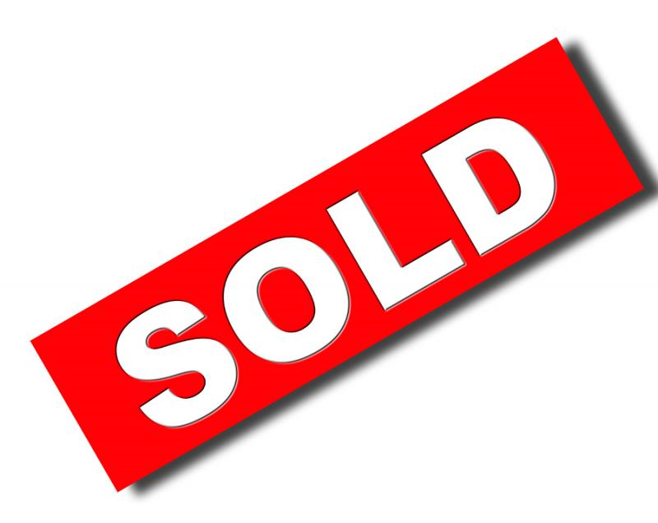
5K Sponsor $10,000 (Limit 1)
- 5K title inclusion
-Company name featured on Race Day Registration Tents
- Name/logo included on banners
-Dedicated social media mentions on Facebook, Twitter, Instagram and LinkedIn
-Twenty-five (25) complimentary race entries
-Event day announcer recognition
-Company logo on all promotional materials, race shirts and medals (if committed by 8/15), race entry forms, and race bibs
-One (1) 10x10 booth space
-Pre-event advertising (print advertising, e-newsletters, etc.)
-Participation in opening activities
-Option to include materials in runner bags
-Recognition on a cheer sign
-Headline newsletter recognition
-Website headline recognition
-Category exclusivity
-First right of renewal in 2023

Title Sponsor $15,000 (Limit 1)
-Company name featured in event title
-Company name featured at Packet Pickup
-Name/logo prominently displayed on banners & signage
-Dedicated social media mentions on Facebook, Twitter, Instagram and LinkedIn
-Twenty-five (25) complimentary race entries
-Event day announcer recognition
-Company logo on all promotional materials, race shirts and medals (if committed by 8/15), race entry forms, and race bibs
-One (1) 10x10 booth space
-Pre-event advertising (print advertising,
e-newsletters, etc.)
-Participation in opening activities
-Option to include materials in runner bags
-Recognition on a cheer sign
-Headline newsletter recognition
-Website headline recognition
-Category exclusivity
-First right of renewal in 2023
Race Day Sponsor $5,000
-Name recognition in title of event
-Fifteen (15) complimentary race entries
-Event day announcer mention
-Company logo on all promotional materials, race shirts (if committed by 8/15), race entry forms, and race bibs
-One (1) 10x10 booth space
-Pre-event advertising (print, radio, e-marketing, etc.)
-Participation in opening activities, introductions and/or race start
-Option to include materials in runner bags
-Recognition on a cheer sign
-Headline newsletter recognition
-Website headline recognition
-Category exclusivity
-First rights of renewal in 2023
1 Mile Fun Run Sponsor $7,500 (Limit 1)
-Fun Run title inclusion
-Twenty (20) complimentary race entries
-Event day announcer mention
-Company logo on all promotional materials, race shirts (if committed by 8/15), race entry forms, and race bibs
-One (1) 10x10 booth space
-Pre-event advertising (print, radio, e-marketing, etc.)
-Participation in opening activities, introductions and/or race start
-Option to include materials in runner bags
-Recognition on a cheer sign
-Headline newsletter recognition
-Website headline recognition
-Category exclusivity
-First right of renewal in 2023
Food Tent Sponsor $2,500
-Sign recognition at the food tents area
-Materials distribution in race packets
-Recognition on a cheer sign
-Ten (10) complimentary race entries
-Website link to company website
-Logo on race shirt (if committed by 8/15)
-One (1) 10x10 booth space

Photo Booth Sponsor $3,000 (limit 1)
-Sponsor logo on each photo
-Sign recognition at photo booth
-Materials distribution in race packets
-Recognition on a cheer sign
-Thirteen (13) complimentary race entries
-Website link to company website
-Logo on race shirt (if committed by 8/15)
-One (1) 10x10 booth space
-First right of renewal in 2023

Registration Sponsor $1,500
-Sign recognition at registration tables
-Volunteers invited to work registration
-Materials distribution in race packets
-Recognition on a cheer sign
-Eight (8) complimentary race entries
-Website link to company website
-Logo on race shirt (if committed by 8/15)

Race Medal Sponsor $5,000 (limit 1)
-Company name/logo on all race medals (if committed by August 1)
-Fifteen (15) complimentary race entries
-Event day announcer mention
-Company logo on all promotional materials, race shirts (if committed by 8/15), race entry forms, and race bibs
-One (1) 10x10 booth space
-Pre-event advertising (print, radio, e-marketing, etc.)
-Option to include materials in runner bags
-Recognition on a cheer sign
-Headline newsletter recognition
-Website headline recognition
-Category exclusivity
-First right of renewal in 2023

Start & Finish Line Sponsor $2,500
-Sign recognition at the start/finish line
-Materials distribution in race packets
-Recognition on a cheer sign
-Ten (10) complimentary race entries
-Website link to company website
-Logo on race shirt (if committed by 8/15)
-One (1) 10x10 booth space

Presenting Sponsor $5,000 (limit 1)
-Name recognition in title of event
-Fifteen (15) complimentary race entries
-Event day announcer mention
-Company logo on all promotional materials, race shirts (if committed by 8/15), race entry forms, and race bibs
-Dedicated mentions on Facebook, Twitter, Instagram
-One (1) 10x10 booth space
-Pre-event advertising (print, radio, e-marketing, etc.)
-Option to include materials in runner bags
-Recognition on a cheer sign
-Headline newsletter recognition
-Website headline recognition
-Category exclusivity
-First right of renewal in 2023

Fido Sponsor $1,000
-Signage at doggie water stops
-Logo placement on Fido Goody Bags
-Materials distribution in race packets
-Recognition on a cheer sign
-Five (5) complimentary race entries
-Website link to company website
-Logo on race shirt (if committed by 8/15)

Goody Bag Sponsor $1,000 (limit 1)
-Sponsor provides bags for 750 racers
-Shared sign recognition on racecourse
-Materials distribution in race packets
-Recognition on a cheer sign
-Five (5) complimentary race entries
-Website link to company website
-Logo on race shirt (if committed by 8/15)

Family Mile Marker Sponsor $1,000
-Sign recognition at designated mile marker
-Materials distribution in race packets
-Recognition on a cheer sign
-Five (5) complimentary race entries
-Website link to company website
-Logo on race shirt (if committed by 8/15)

Hydration Station Sponsor $1,000 (limit 3)
-Sign recognition at water station on the course
-Invited to have volunteers work water station
-Materials distribution in race packets
-Recognition on a cheer sign
-Five (5) complimentary race entries
-Website link to company website
-Company name listed on race shirt (if committed by 8/15)

-Logo on race shirt

Booth Sponsor $250
-One (1) 10x10 booth space
-Materials distribution in race packets
-Two (2) complimentary race entries

Pacesetter Sponsor $500
-Materials distribution in race packets
-Recognition on a cheer sign
-Three (3) complimentary race entries
-Company name listed on race shirt (if committed by 8/15)

Cheer Sign Sponsor $200
-Shared sign recognition along racecourse
-Materials distribution in race packets
-One (1) complimentary race entry

Race Packet Materials $25
-Materials distribution in race packets

I would like to participate as the:

___ Title Sponsor at $15,000
___ 5K Title Sponsor at $10,000
___1-Mile Fun Run Sponsor at $7,500
___Race Day Sponsor at $5,000
___Presenting Sponsor at $5,000
___ Medal Sponsor at $5,000
___ Photo Booth Sponsor at $3,000
___Food Tent Sponsor at $2,500
___ Start & Finish Line Sponsor at $2,500
___ Registration Sponsor at $1,500
___ Fido Sponsor at $1,000
___Goody Bag Sponsor at $1,000
___ Family Mile Marker Sponsor at $1,000
___ Hydration Station Sponsor at $1,000
___ Pacesetter Sponsor at $500
___ Booth Sponsor $250
___ Cheer Sign Sponsor at $200
___ Race Packet Materials at $25

___ I am unable to participate in the Hustle for the House, but enclosed is my donation of:
____ $1,000 ____ $500 ____$250 ____ $100 ____ Other

Name _______________________________________________________________

Email _______________________________________________________________

Company _____________________________________________________________

Address ______________________________________________________________

City _______________________ State ____TN_____ Zip _________________

Work Phone _______________ Home Phone _________________Fax ______________

I would like to pay by: Check _____ MasterCard _____ VISA _____ AMEX _____

Total enclosed: $ ___________.

____________________________________________________________________
Card Number Expiration Date CVV

_________________________________________________________________
Name as it appears on Credit Card (Please print)

_________________________________________________________________
Billing Address for Credit Card (Please print Street/City/State/Zip or indicate same as address above)

Sponsors will receive additional information to register their complimentary race participants.
Please return this form to liz@rmhcnashville.com, fax to 615-343-4004 or mail to 2144 Fairfax Avenue, Nashville, TN 37212.

