Join us on Saturday, September 21, 2024, for the Hustle for the House 5K and 1-Mile Fun Run benefiting Ronald McDonald House Charities of Nashville. The race will start and finish at the Nashville Ronald McDonald House and follow a certified course through the Hillsboro West End Neighborhood. You can also get moving as part of our virtual run and participate wherever you are. All participants, both virtual and in person, are invited to dress in their finest disco attire if the mood strikes!

Race times: 7:30 a.m. for the 1-Mile Fun Run
8:00 a.m. for the 5K

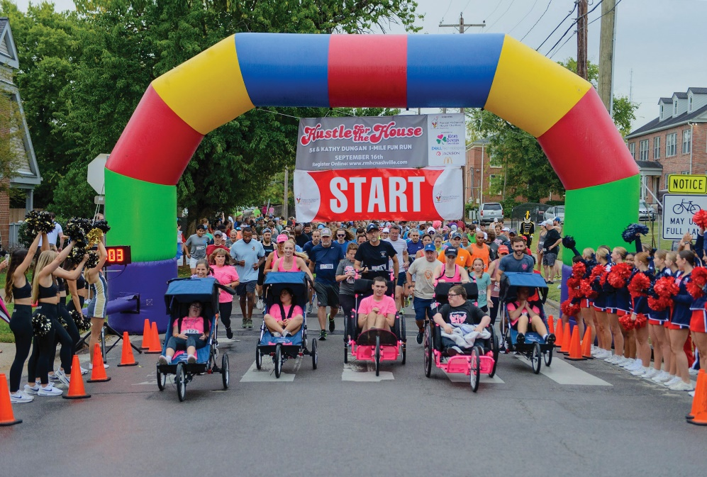
Early Bird Pricing: Now through July 30
- 5K Run - $30
- 1-Mile Run- $25
- Virtual or Spirit Run - $30
- Fido - $10

Regular Registration: 7/31 – 9/19
- 5K Run - $35
- 1-Mile Run-$30
- Virtual or Spirit Run - $35
- Fido - $12

Race Day Registration: (9/20 & 9/21)
- 5K Run - $40
- 1-Mile - $40
- Virtual or Spirit Run - $40
- Fido - $15

Only pre-registered participants are guaranteed a t-shirt; t-shirts for day of race registrants will be available on a first come, first-served basis.

How You Can Help:
Sponsorship – Ranging from $200 to $10,000, these packages allow your company name to be associated with the Hustle for the House 5K and 1-Mile Fun Run prior to and during the event. Call 615-343-4000 or email liz@rmhcnashville.com for information.
Race Teams – Gather your friends, grab your family, and form a team for RMHC of Nashville. We encourage you to wear t-shirts displaying your team/company name or logo on race day. Team pages are easy to build on our registration site!
Corporate Matching Program – As an employer, you may choose to pay for all or a portion of your employees’ entry fee or provide matching funds for the entry fees and/or pledge dollars they raise. This is a great way to show your corporation’s commitment to the families of critically ill children.
In-Kind Sponsorship – We accept goods and services on a case-by-case basis.
5K Sponsor $10,000 (Limit 1)
- 5K title inclusion
-Company name featured on Race Day Registration Tents
- Name/logo included on banners
-Dedicated social media mentions on Facebook, Twitter, Instagram, and LinkedIn
-Twenty-five (25) complimentary race entries
-Event day announcer recognition
-Company logo on all promotional materials, race shirts and medals (if committed by 8/16), race entry forms, and race bibs
-One (1) 10x10 booth space
-Pre-event advertising (print advertising, e-newsletters, etc.)
-Participation in opening activities
-Option to include materials in runner bags
-Recognition on a cheer sign
-Headline newsletter recognition
-Website headline recognition
-Category exclusivity
-First right of renewal in 2025

Title Sponsor $15,000 (Limit 1)
-Company name featured in event title
-Company name featured at Packet Pickup
-Name/logo prominently displayed on banners & signage
-Dedicated social media mentions on Facebook, Twitter, Instagram, and LinkedIn
-Twenty-five (25) complimentary race entries
-Event day announcer recognition
-Company logo on all promotional materials, race shirts and medals (if committed by 8/16), race entry forms, and race bibs
-One (1) 10x10 booth space
-Pre-event advertising (print advertising,
e-newsletters, etc.)
-Participation in opening activities
-Option to include materials in runner bags
-Recognition on a cheer sign
-Headline newsletter recognition
-Website headline recognition
-Category exclusivity
-First right of renewal in 2025
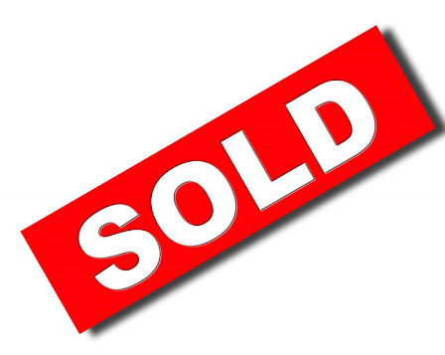
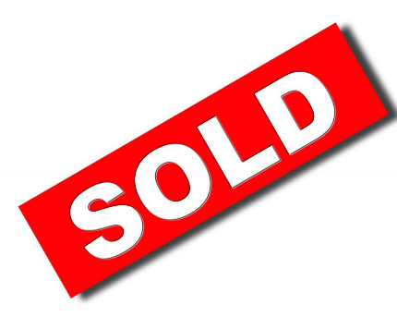
Race Day Sponsor $5,000
-Name recognition in title of event
-Fifteen (15) complimentary race entries
-Event day announcer mention
-Company logo on all promotional materials, race shirts (if committed by 8/16), race entry forms, and race bibs
-One (1) 10x10 booth space
-Pre-event advertising (print, radio, e-marketing, etc.)
-Participation in opening activities, introductions and/or race start
-Option to include materials in runner bags
-Recognition on a cheer sign
-Headline newsletter recognition
-Website headline recognition
-Category exclusivity
-First rights of renewal in 2025
1 Mile Fun Run Sponsor $7,500 (Limit 1)
-Fun Run title inclusion
-Twenty (20) complimentary race entries
-Event day announcer mention
-Company logo on all promotional materials, race shirts (if committed by 8/16), race entry forms, and race bibs
-One (1) 10x10 booth space
-Pre-event advertising (print, radio, e-marketing, etc.)
-Participation in opening activities, introductions and/or race start
-Option to include materials in runner bags
-Recognition on a cheer sign
-Headline newsletter recognition
-Website headline recognition
-Category exclusivity
-First right of renewal in 2025
Food Tent Sponsor $2,500
-Sign recognition at the food tents area
-Materials distribution in race packets
-Recognition on a cheer sign
-Ten (10) complimentary race entries
-Website link to company website
-Logo on race shirt (if committed by 8/16)
-One (1) 10x10 booth space

Photo Booth Sponsor $3,000 (limit 1)
-Sponsor logo on each photo
-Sign recognition at photo booth
-Materials distribution in race packets
-Recognition on a cheer sign
-Thirteen (13) complimentary race entries
-Website link to company website
-Logo on race shirt (if committed by 8/16)
-One (1) 10x10 booth space
-First right of renewal in 2025

Goody Bag Sponsor $1,000 (limit 1)
-Sponsor provides bags for 750 racers
-Shared sign recognition on racecourse
-Materials distribution in race packets
-Recognition on a cheer sign
-Five (5) complimentary race entries
-Website link to company website
-Logo on race shirt (if committed by 8/16)

Presenting Sponsor $5,000 (limit 1)
-Name recognition in title of event -Fifteen (15) complimentary race entries
-Event day announcer mention -One (1) 10x10 booth space
-Option to include materials in runner bags -Recognition on a cheer sign
-Dedicated mentions on Facebook, Twitter, Instagram -Newsletter & Website Recognition
-Pre-event advertising (print, radio, e-marketing, etc.) -Category exclusivity
-Company logo on all promotional materials, race shirts (if committed by 8/16), race entry forms, and race bibs
-First right of renewal in 2025

Race Medal Sponsor $5,000 (limit 1)
-Company name/logo on all race medals (if committed by August 1)
-Fifteen (15) complimentary race entries
-Event day announcer mention
-Company logo on all promotional materials, race shirts (if committed by 8/16), race entry forms, and race bibs
-One (1) 10x10 booth space
-Pre-event advertising (print, radio, e-marketing, etc.)
-Option to include materials in runner bags
-Recognition on a cheer sign
-Headline newsletter recognition
-Website headline recognition
-Category exclusivity
-First right of renewal in 2025
Start & Finish Line Sponsor $2,500
-Sign recognition at the start/finish line
-Materials distribution in race packets
-Recognition on a cheer sign
-Ten (10) complimentary race entries
-Website link to company website
-Logo on race shirt (if committed by 8/16)
-One (1) 10x10 booth space

Fido Sponsor $1,000
-Signage at dog water stops
-Logo placement on Fido Goody Bags
-Materials distribution in race packets
-Recognition on a cheer sign
-Five (5) complimentary race entries
-Website link to company website
-Logo on race shirt (if committed by 8/16)

Hydration Station Sponsor $1,000 (limit 3)
-Sign recognition at water station on the course
-Invited to have volunteers work water station
-Materials distribution in race packets
-Recognition on a cheer sign
-Five (5) complimentary race entries
-Website link to company website
-Company name listed on race shirt (if committed by 8/16)
Registration Sponsor $1,500
-Sign recognition at registration tables
-Volunteers invited to work registration
-Materials distribution in race packets
-Recognition on a cheer sign
-Eight (8) complimentary race entries
-Website link to company website
-Logo on race shirt (if committed by 8/16)

Family Mile Marker Sponsor $1,000
-Sign recognition at designated mile marker
-Materials distribution in race packets
-Recognition on a cheer sign
-Five (5) complimentary race entries
-Website link to company website
-Logo on race shirt (if committed by 8/16)

Booth Sponsor $250
-One (1) 10x10 booth space
-Materials distribution in race packets
-Two (2) complimentary race entries

Race Packet Materials $25
-Materials distribution in race packets

Pacesetter Sponsor $500
-Materials distribution in race packets
-Recognition on a cheer sign
-Three (3) complimentary race entries
-Company name listed on race shirt (if committed by 8/16)

Race Advertising Partner – In-Kind Value (see attached)
-Materials distribution in race packets
- Three (3) complimentary race entries
- Pre-event advertising (print, e-marketing, social media etc.)
-Event day announcer mention
- Recognition on a cheer sign on the course
-Logo and website link on the RMHC of Nashville event page
-Logo on race shirt (if committed by 8/16)

Cheer Sign Sponsor $200
-Shared sign recognition along racecourse
-Materials distribution in race packets
-One (1) complimentary race entry

Race Radio Partner – In-Kind Value (see attached)
-Materials distribution in race packets
- Thirteen (13) complimentary race entries
- Pre-event advertising (print, e-marketing, social media etc.)
-Event day announcer mention
- Recognition on a cheer sign on the course
-Logo and radio website link on the RMHC of Nashville event page
-Logo on race shirt (if committed by 8/16)
-One (1) 10x10 booth space
-First right of renewal in 2024

I would like to participate as the:

__ Title Sponsor at $15,000

__ 5K Title Sponsor at $10,000
__ 1-Mile Fun Run Sponsor at $7,500
__ Race Day Sponsor at $5,000
__ Presenting Sponsor at $5,000
__ Medal Sponsor at $5,000
__ Photo Booth Sponsor at $3,000
___Food Tent Sponsor at $2,500
__ Start & Finish Line Sponsor at $2,500
__ Registration Sponsor at $1,500
__ Fido Sponsor at $1,000
__ Goody Bag Sponsor at $1,000
__ Family Mile Marker Sponsor at $1,000
__ Hydration Station Sponsor at $1,000
__ Pacesetter Sponsor at $500
__ Booth Sponsor $250
__ Cheer Sign Sponsor at $200
__ Race Packet Materials at $25
__ Race Radio Partner (In-Kind)
__ Race Advertising Partner (In-Kind)

___ I am unable to participate in the Hustle for the House, but enclosed is my donation of:
____ $1,000 ____ $500 ____$250 ____ $100 ____ Other

Name______________________________________________________________________

Company___________________________________________________________________

Street Address________________________________________________________________

City ____________________________________ State ___________ Zip _________________

Phone ________________ Email_________________________________________________

I would like to pay by: Check _____ MasterCard _____ VISA _____ AMEX _____ Discover _____

Total enclosed: $ ___________.

__________________________________________________________________________
Card Number Expiration Date CVV

_______________________________________________________________________
Name as it appears on Credit Card (Please print)

_______________________________________________________________________
Billing Address for Credit Card (Please print Street/City/State/Zip or indicate same as address above)

Sponsors will receive additional information to register their complimentary race participants.
Please return this form to liz@rmhcnashville.com, fax to 615-343-4004 or mail to
2144 Fairfax Avenue, Nashville, TN 37212.

