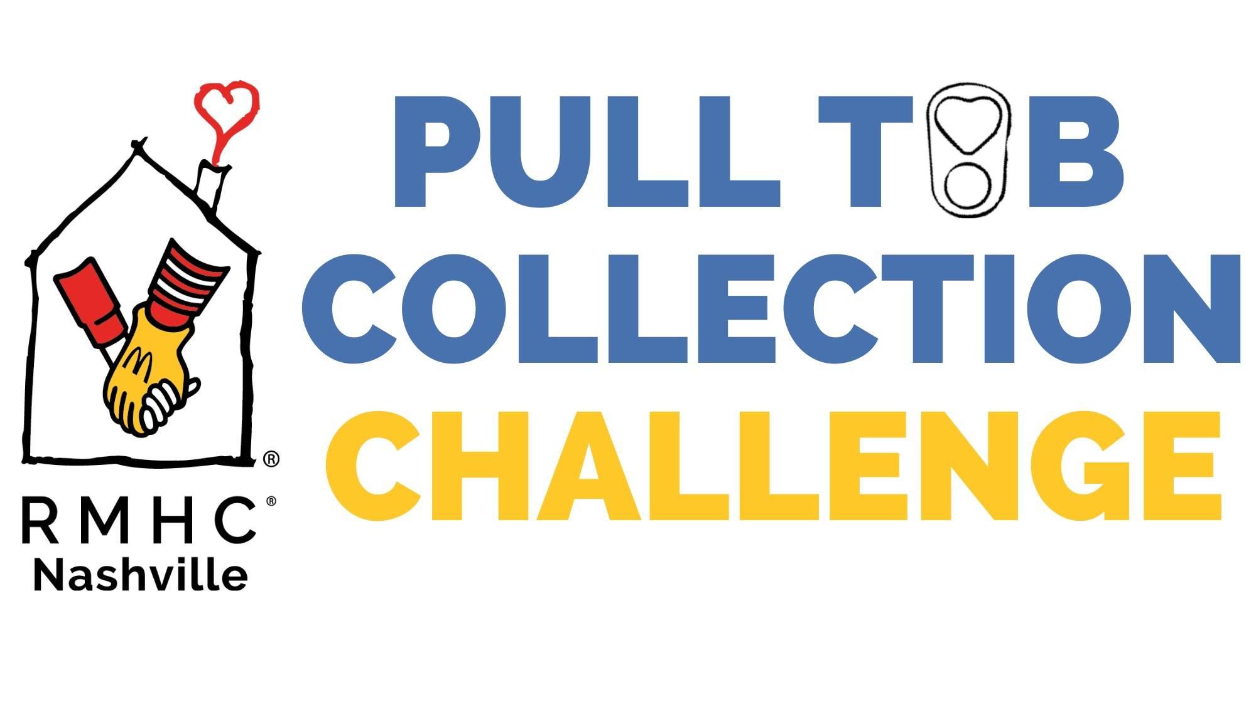

Benefitting
Ronald McDonald House Charities of Nashville

2024 Registration Form
Please print clearly

School / Group / Company Name:____________________________________________________

Mailing Address: ____________________________________________________________________

________________________________________________________________________

________________________________________________________________________

City________________________________State_______________Zip_______________

County Where Your School / Group / Company is Located:______________________________

School Principal: __________________________________________________________________

Principal E-mail: __________________________________________________________________

Primary Contact: __________________________________________________________________

Primary Contact E-mail: ______________________________________________________________

Telephone:(_________)_______________________________________________________________

Fax: (_________)_____________________________________________________________________

Number of students /individuals participating from your school / group / company:________

Email Completed Form to: liz@rmhcnashville.com
Or
Fax Completed Form to: 615-343-4004
Or
Mail Form to: Ronald McDonald House Charities of Nashville, 2144 Fairfax Avenue, Nashville, TN 37212

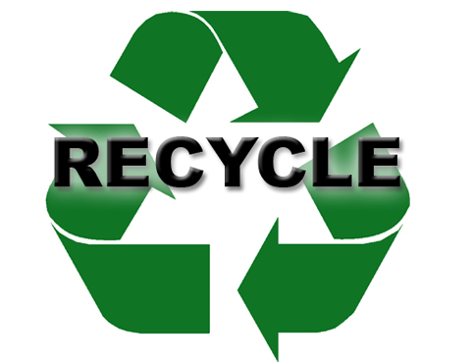
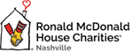
SEND IN YOUR REGISTRATION TODAY!!

