**Pull Tab Fundraising Program**

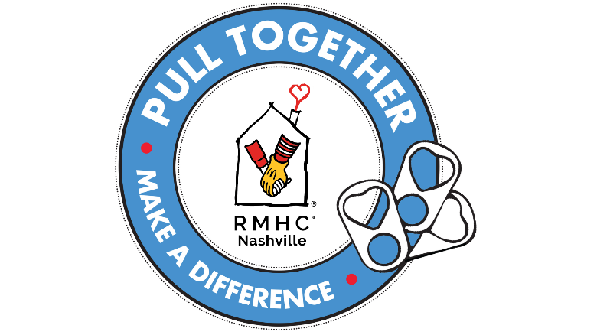Did you know that the pull tab from any aluminum can (soft drink, beverage, cat food or soup can) is part of a major fundraising effort for Ronald McDonald House Charities of Nashville? By simply saving the tiny pull tab, you can help raise hundreds of dollars to support the families of critically ill children receiving treatment at Nashville area hospitals.  
  
The Pull Tab Program invites people of all ages to collect aluminum tabs from beverage cans, soup cans, etc. to directly support Ronald McDonald House Charities of Nashville. Thanks to our agreement with a local recycling company, the tabs are recycled and turned into a monetary donation for RMHC of Nashville. Individuals, schools, clubs, and businesses can join in the fun!

So why save the pull tab and not the entire can? Although the whole can is valuable, the tab is much cleaner and easier to collect in large quantities, while also being made of high-grade aluminum. By itself, a tab doesn’t seem like much, but when we pull together, even small tabs can make a big difference for the families we serve.

Here are some tips for joining us in “Pulling for the Ronald McDonald House.”

* Find or create a pull tab container. Pull tabs can be collected in just about anything! Consider using an old milk jug, box, coffee can, or garbage can. You can even download a collection container wrap from the pull tab website. Feeling crafty? Create an eye-catching container that can help raise interest in and awareness of your collection.
* Place your container in a convenient, visible location, whether in your home, meeting space or community kitchen.
* Start collecting aluminum tabs. (Don’t forget to recycle the remaining part of the can!) Make it fun by challenging family, friends, and co-workers to help with your collection!
* Encourage each member of your organization to participate, no matter how many they collect - every tab counts! It takes approximately 1,200 pull tabs to equal one pound.
* Drop off your collection! Pull tabs can be dropped off or mailed to 2144 Fairfax Avenue, Nashville, TN 37212. Or you can drop off your collection at our annual Pull Tab Collection Challenge Drop Day Celebration which takes place in November every year.

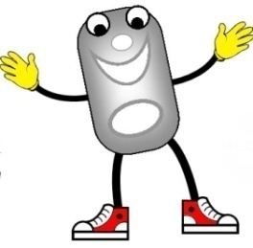Next time you open a can, please pull for Ronald McDonald House Charities of Nashville!

***Pull tabs can be dropped off or mailed to the***

***Nashville Ronald McDonald House (2144 Fairfax Avenue Nashville, TN 37212)***

***7 days a week from 8:00 a.m. to 8:00 p.m.!***